Step – 1: Create Custom Profiles
In our Project we need 3 main profiles –
- NGO Admin (who had full access on the app)
- Donor Manager (who had access for donor object and event object)
- Volunteer Coordinator (who had access for volunteer and event objects)
Home -> Quick Find (Search Profiles)
- Clone “Standard User” & create those 3 profiles one by one & save.
- NGO Admin, Volunteer Coordinator, Donor Manager
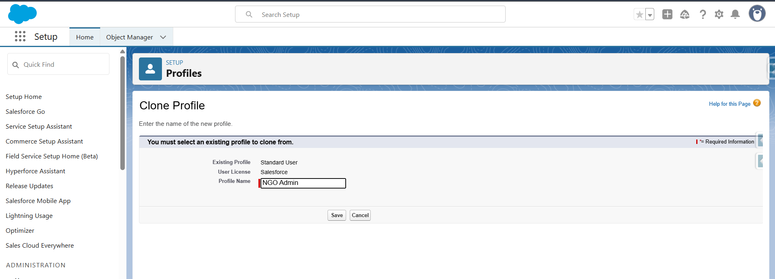

Step – 2: Create Custom Objects
In our app we need to create 3 custom objects called Donation, Volunteer, Event.
Go to Setup → Object Manager → Create → Custom Object
For each object, check:
  - All Optional Features
  - Deployment Status -> Deployed
  - Allow Search
  - Object Creation Options (Available only when custom object is first created): (Check both)
It will open the custom object tab page
- Choose any tab style -> next
- In the Apply one tab visibility to all profiles select Tab Hidden & click Apply a different tab visibility for each profile option, so that we can add only our required profiles (System Administrator, Donor Manager, NGO Admin, Volunteer Coordinator) for the object. So, select default on for only those 4 profiles
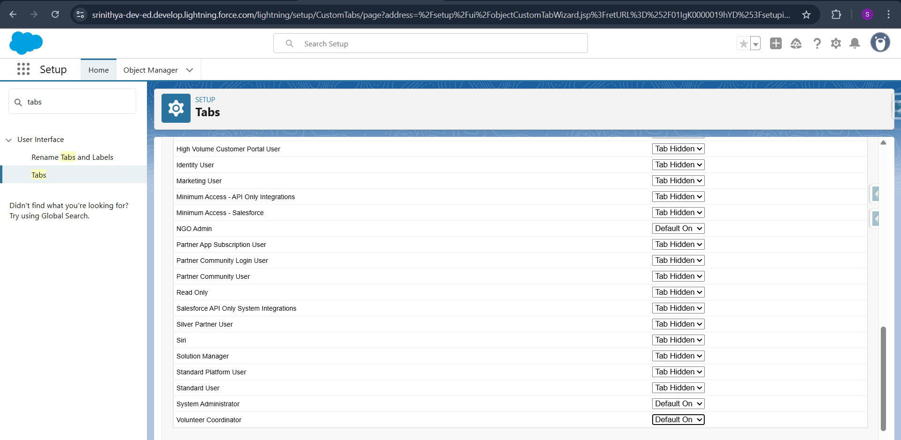
- Click Next -> In step 3 uncheck Include tab & save.
Step – 3: Add Custom Fields
- Donation Object
Field Label | Data Type
Donor Name | Text
Email | Email
Phone | Phone
Donation Type | Picklist Multiselect (Money, Food, Clothes, Groceries, Other)
Donation Amount | Currency
Donation Date | Date
Reason | Text Area
Occasion | Picklist (Birthday, Marriage, Health, Death, Other)
Occasion Date | Date
Related Event | Lookup Relationship (Event)
IT Certificate Sent | Checkbox
Notes | Long Text Area
Payment Method | Picklist (UPI, Card, Bank Transfer, Cash, Not Applicable)
Monthly Start Date | Date
Monthly End Date | Date
Frequency | Picklist (Monthly, Bi-monthly, Quarterly)
Auto Renewal | Checkbox

- Volunteer Object
Field Label | Data Type
Volunteer Name | Text
Email | Email
Phone | Phone
Skills | Text Area
Availability | Picklist (Weekdays, Weekends, Anytime)
Participation Date | Date
Assigned Task | Text
Event Participated  Feedback  Wants Notification | Lookup Relationship (Event)  Text area  Checkbox

- Event Object
Field Label | Data Type
Event Name | Text
Event Date | Date
Location | Text
Description | Long Text Area

Step – 4: Create Custom App
In our profile click Switch to Salesforce Classic
- Go to Setup (Classic) → Create → Apps → New
- Name: NGO Management
- Add the tabs: Donation, Volunteer, Event, Reports, Dashboards
- Assign to: System Administrator, NGO Admin, Donor Manager, Volunteer Coordinator profiles.

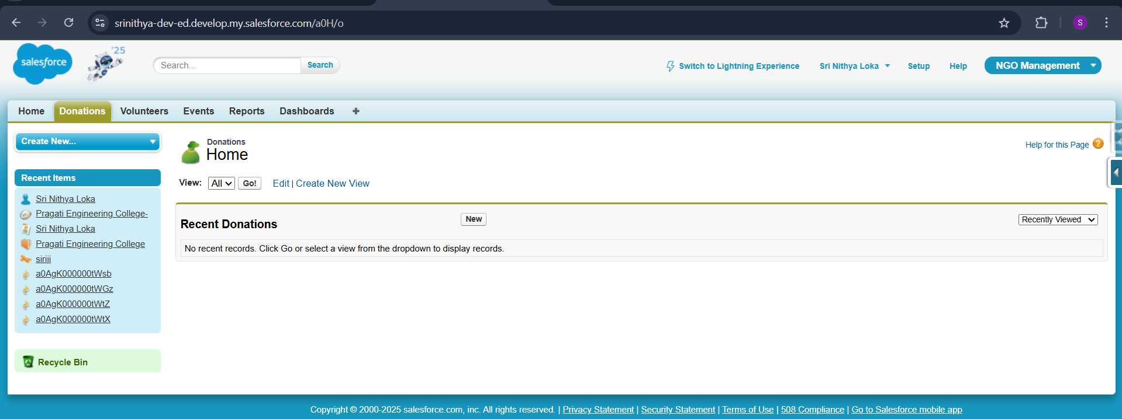
Switch to Lightning Process
- In Quick Find -> App Manager
- Go to NGO Management -> Edit -> Check Show in Lightning Experience

Step – 5: Set Field-Level Security (FLS)
- Quick Find -> Profiles -> Open NGO Admin -> click edit
- For Custom App Settings -> The NGO Admin profile should be in only our NGO Management. So, uncheck all the apps and check only for NGO Management.
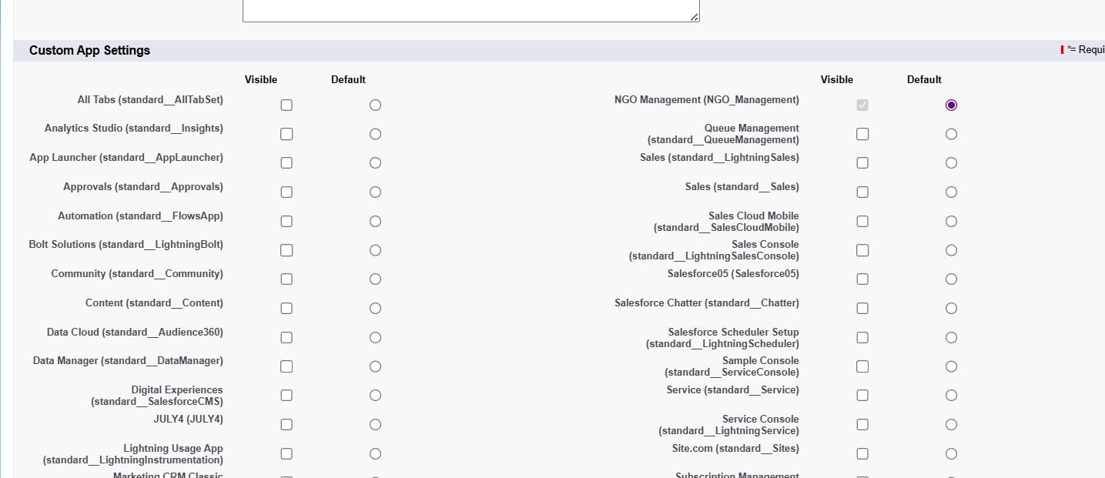
- Scroll down for custom tab settings -> As we know NGO Admin will have full access So, we have to keep default on for our 3 objects: Donations, Events, Volunteers & keep every other tabs as Tab hidden
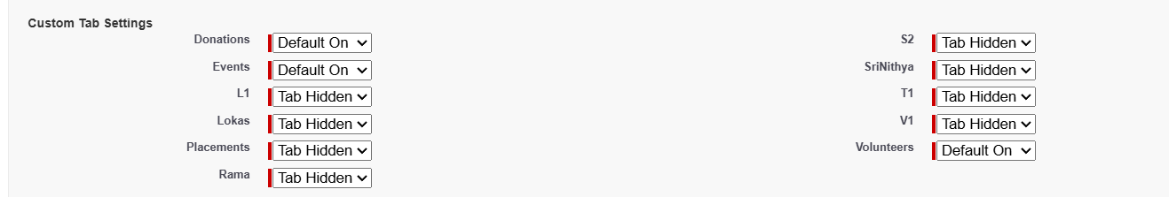
- Scroll down for Custom Object Permissions & give all the access to the 3 objects.
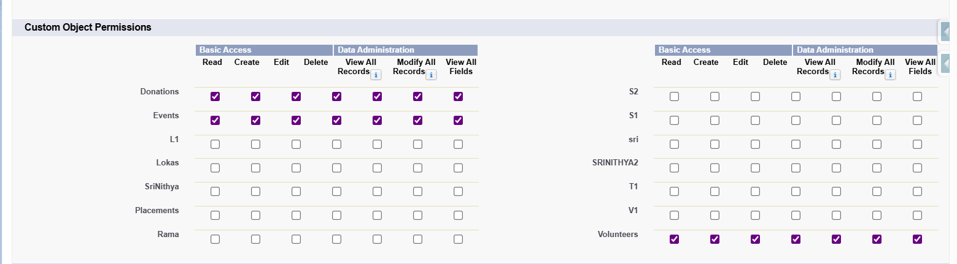
- Click save.
Now we will go to the Donor Manager Profile & click edit
- Check Only NGO Management in the Custom App settings & uncheck all other apps
- Scroll down to Custom Tab Settings & keep Default on only for Donations & Events and keep other tabs as Tab Hidden.
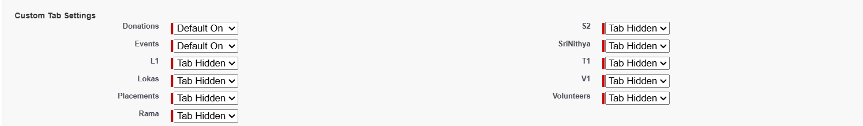
- Scroll down to Custom Object permissions
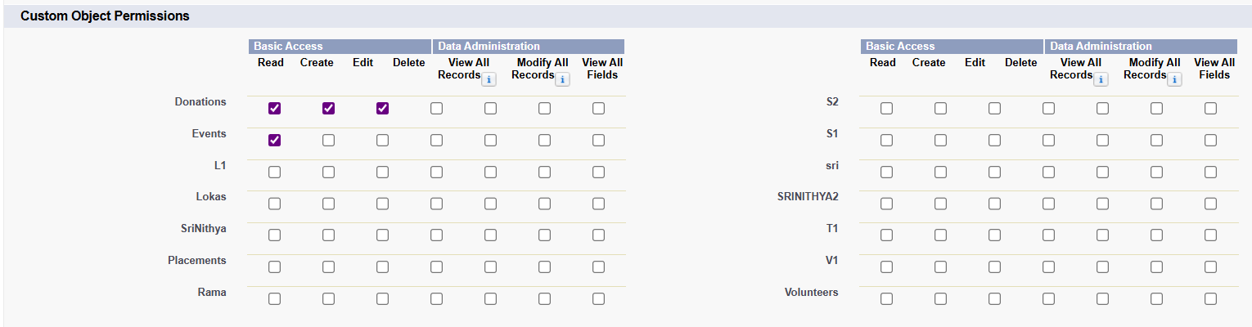
- Click save.

Now we will go to the Volunteer Coordinator Profile & click edit
- Check Only NGO Management in the Custom App settings & uncheck all other apps
- Scroll down to Custom Tab Settings & keep Default on only for Volunteers & Events and keep other tabs as Tab Hidden.
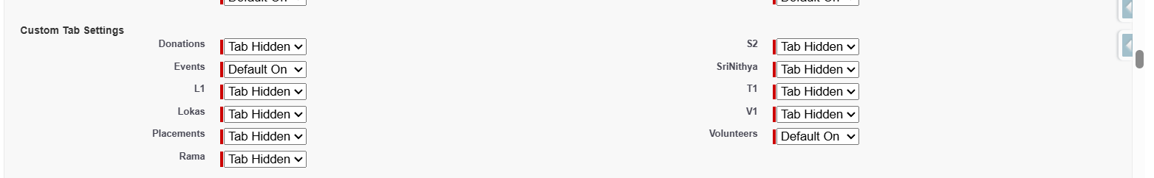
- Scroll down to Custom Object permissions
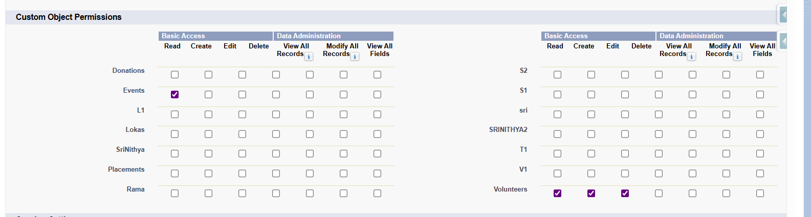
- Click Save
Step – 6: Validation Rules
Validation Rule:
A Validation Rule is a rule that checks the data entered into a record and prevents saving if the data is incorrect or incomplete.
Go to Object Manager -> Donation -> Validation rules -> Click New
- Donation Amount must be > 0 if type is Money
- Name: Validate_Donation_Amount_If_Money
- Formula: AND(
INCLUDES(Donation_Type__c, "Money"),
Donation_Amount__c <= 0
)
- Check Syntax
- Error Message: Donation amount must be greater than 0 if the donation type is Money.
- Error Location: Select Field instead of Top of Page -> Donation Amount
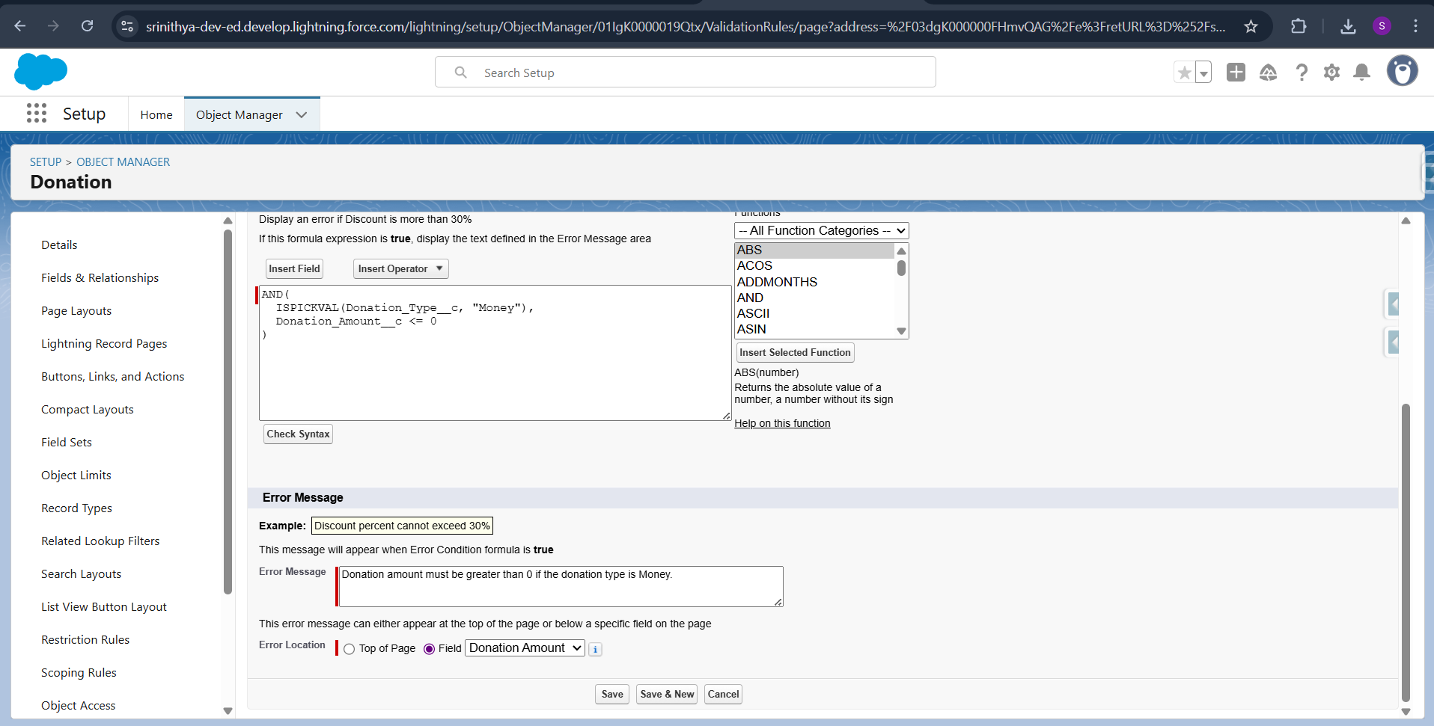
- Email must contain “@” symbol
- Name: Validate_Email_Format
- Formula: NOT(CONTAINS(Email__c, "@"))
- Check Syntax
- Error Message: Please enter a valid email address.
- Error Location: Select Field instead of Top of Page -> Email field

- Occasion Date must be filled if Occasion ≠ None
- Name: Validate_Occasion_Date
- Formula: AND(
$RecordType.DeveloperName = "One_Time_Donation",
NOT(ISPICKVAL(Occasion__c, "None")),
OR(
ISBLANK(Occasion_Date__c),
Occasion_Date__c < DATEVALUE(CreatedDate)
)
)

- Check Syntax
- Error Message: Occasion Date is required when an occasion is selected.
- Error Location: Occasion Date field

- Phone Number should be 10 digits
- Name: Validate_Phone_Format
- Formula: AND(
NOT(ISBLANK(Phone__c)),
NOT(
REGEX(
Phone__c,
"^(\\(?\\d{3}\\)?[-.\\s]?\\d{3}[-.\\s]?\\d{4})$"
)
)
)
- Check Syntax
- Error Message: Phone number must be 10 digits.
- Error Location: Phone field

Go to Object Manager -> Volunteer -> Validation rules -> Click New
- Email must contain “@” symbol
- Name: Validate_Email_Format
- Formula: NOT(CONTAINS(Email__c, "@"))
- Check Syntax
- Error Message: Please enter a valid email address.
- Error Location: Select Field instead of Top of Page -> Email field

- Phone Number should be 10 digits
- Name: Validate_Phone_Format
- Formula: AND(
NOT(ISBLANK(Phone__c)),
NOT(
REGEX(
Phone__c,
"^(\\(?\\d{3}\\)?[-.\\s]?\\d{3}[-.\\s]?\\d{4})$"
)
)
)
- Check Syntax
- Error Message: Phone number must be 10 digits.
- Error Location: Phone field

Step – 7: Create Page Layouts for Donation Object
Donors can donate in two ways: Monthly & One - time donation
So, we need to create appropriate page layouts: One page layout will be created by default when we create the object (Donation Layout) -> We use this layout for One time Donation form.
- Set up -> Object Manager -> Donation ->Page layout- -> Donation Layout
Here drag the fields
Donor Name, Email, Phone, Donation Type, Donation Amount, Payment Method, Donation Date, Reason, Occasion, Occasion Date, Occasion Date, IT Certificate Sent,Notes

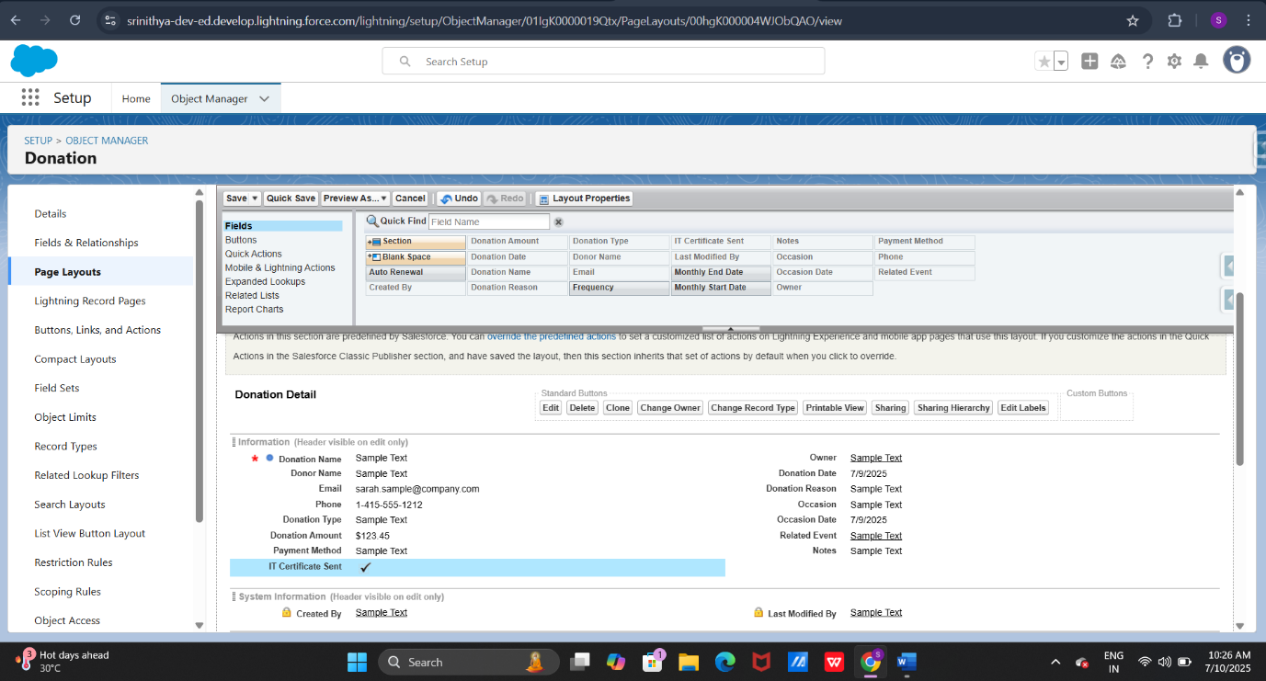 Now we need to create a new page layout as Monthly for this,
- Set up--> object Manager-->Donation-->Page Layout-->New-->Name as Monthly-->
Now drag the fields to the form
Donor Name, Email, Phone, Donation Type, Donation Amount, Payment Method,
IT Certificate Sent, Monthly Start Date, Monthly End Date, Frequency, Auto Renewal, Notes

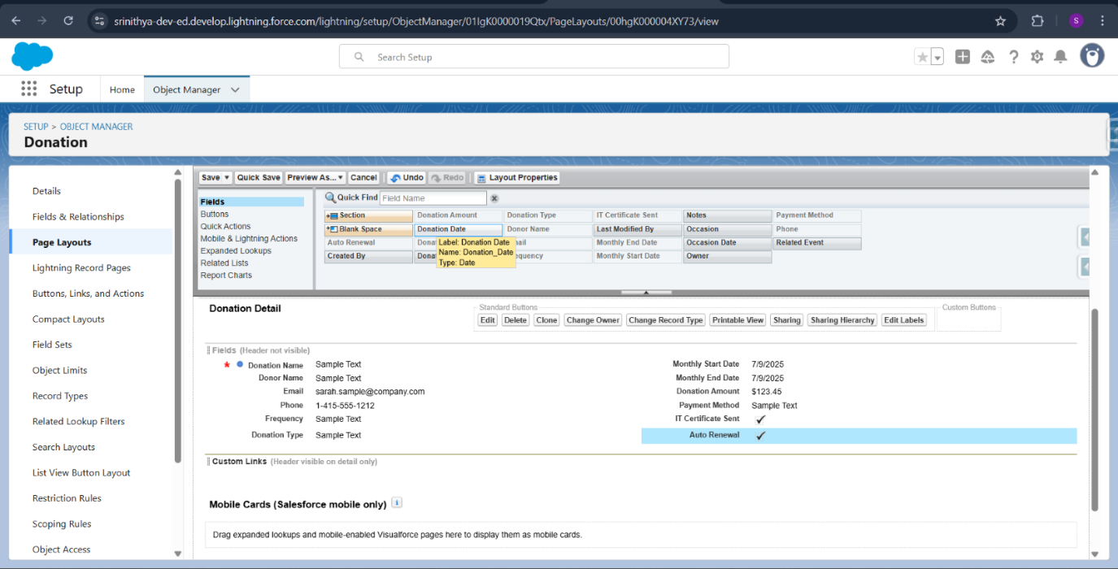
- Creating page layout for volunteer object for registration purpose
- Now we are creating the page layout for volunteer object this is for registration purpose
- Set up--> object Manager -->Volunteer -->page Layout-->Volunteer page layout
- Here required fill are Email,Phone,Skills,Availability so drag the remaining fields to up
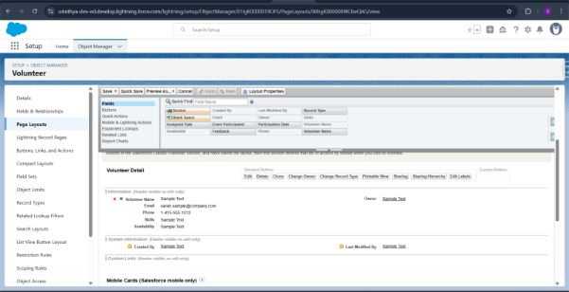
- Creating Another page layout for the volunteer object for feedback purpose
- Set up-->Object Manager -->Volunteer -->Page Layout -->New -->Label : Feedback
- Drag the fileds down Phone,Email,Event participation,participation Event,Assigned Task ,Feedback
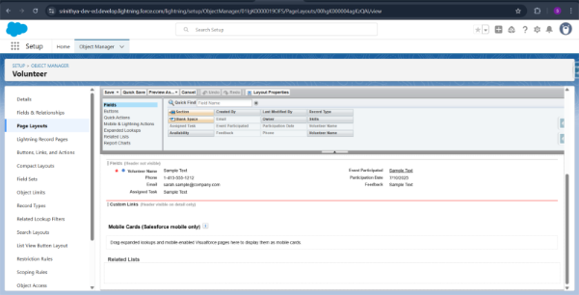

Step 8 - Create a record type for Donation object
One Time Donation
- Set up->object Manager-> Donation ->Record Type ->New
- Record Type label --> One Time Donation
- Set Make Available for Donor Manager, NGO admin, System Administrator, Volunteer Coordinator
- Click Next, Select Apply page layout as One Time Donation
- Click Save
Monthly Donation
- Set up->object Manager->Donation ->Record Type ->New
- Record Type label-->Monthly Donation
- Set Make Available for Donor Manager, NGO admin, System Administrator, Volunteer Coordinator
- Click Next, Select Apply page layout as Monthly Donation
- Click Save
Create a record type for Volunteer object
Volunteer Registration
- Set up->object Manager->Volunteer ->Record Type ->New
- Record Type label-->Volunteer Registration
- Set Make Available for Donor Manager, NGO admin, System Administrator, Volunteer Coordinator
- Click Next, Select Apply page layout as Volunteer Pagelayout
- Click Save
Volunteer Feedback
- Set up->object Manager->Volunteer ->Record Type ->New
- Record Type label-->Volunteer Feedback
- Set Make Available for Donor Manager, NGO admin, System Administrator, Volunteer Coordinator
- Click Next, Select Apply page layout as Feedback
- Click Save

Step 9 – Create Email Templates
We need to create email templates for sending emails for the
- 2 Email Templates for Donors based on their donations (if the donor donates money, they will get the mail with IT Certification ID & if the donor donates other things instead of money they will get another mail)
- Email Template based on Occasion If the donor fills the occasion as Birthdays, Marriage Anniversary.
- Some donors will donate monthly so we need to send them remainders monthly through emails.
- Volunteers will get Participation email after the event ended, Volunteers get notified when the event is created.
- Quick Find -> Classic Email Templates -> New Template
- Choose Text -> Folder: Unified Public Classic Email Templates -> Check Available for use
- Email Template Name: ThankYou_Money
- Subject: Thank You for Your Generous Donation!!
- Email Body:
Dear {!Donation__c.Donor_Name__c},
Thank you so much for your generous donation of {!Donation__c.Donation_Type__c} on {!Donation__c.Donation_Date__c}.
We truly appreciate your financial support. As a token of appreciation, please find your Income Tax certificate details below:
Certificate ID: IT-{!Donation__c.Id}
Your contribution helps us serve the community better and bring positive change. We are sincerely grateful for your kindness and generosity.
We hope to have your continued support in the future.
Warm regards,
NGO Management Team
- Click save
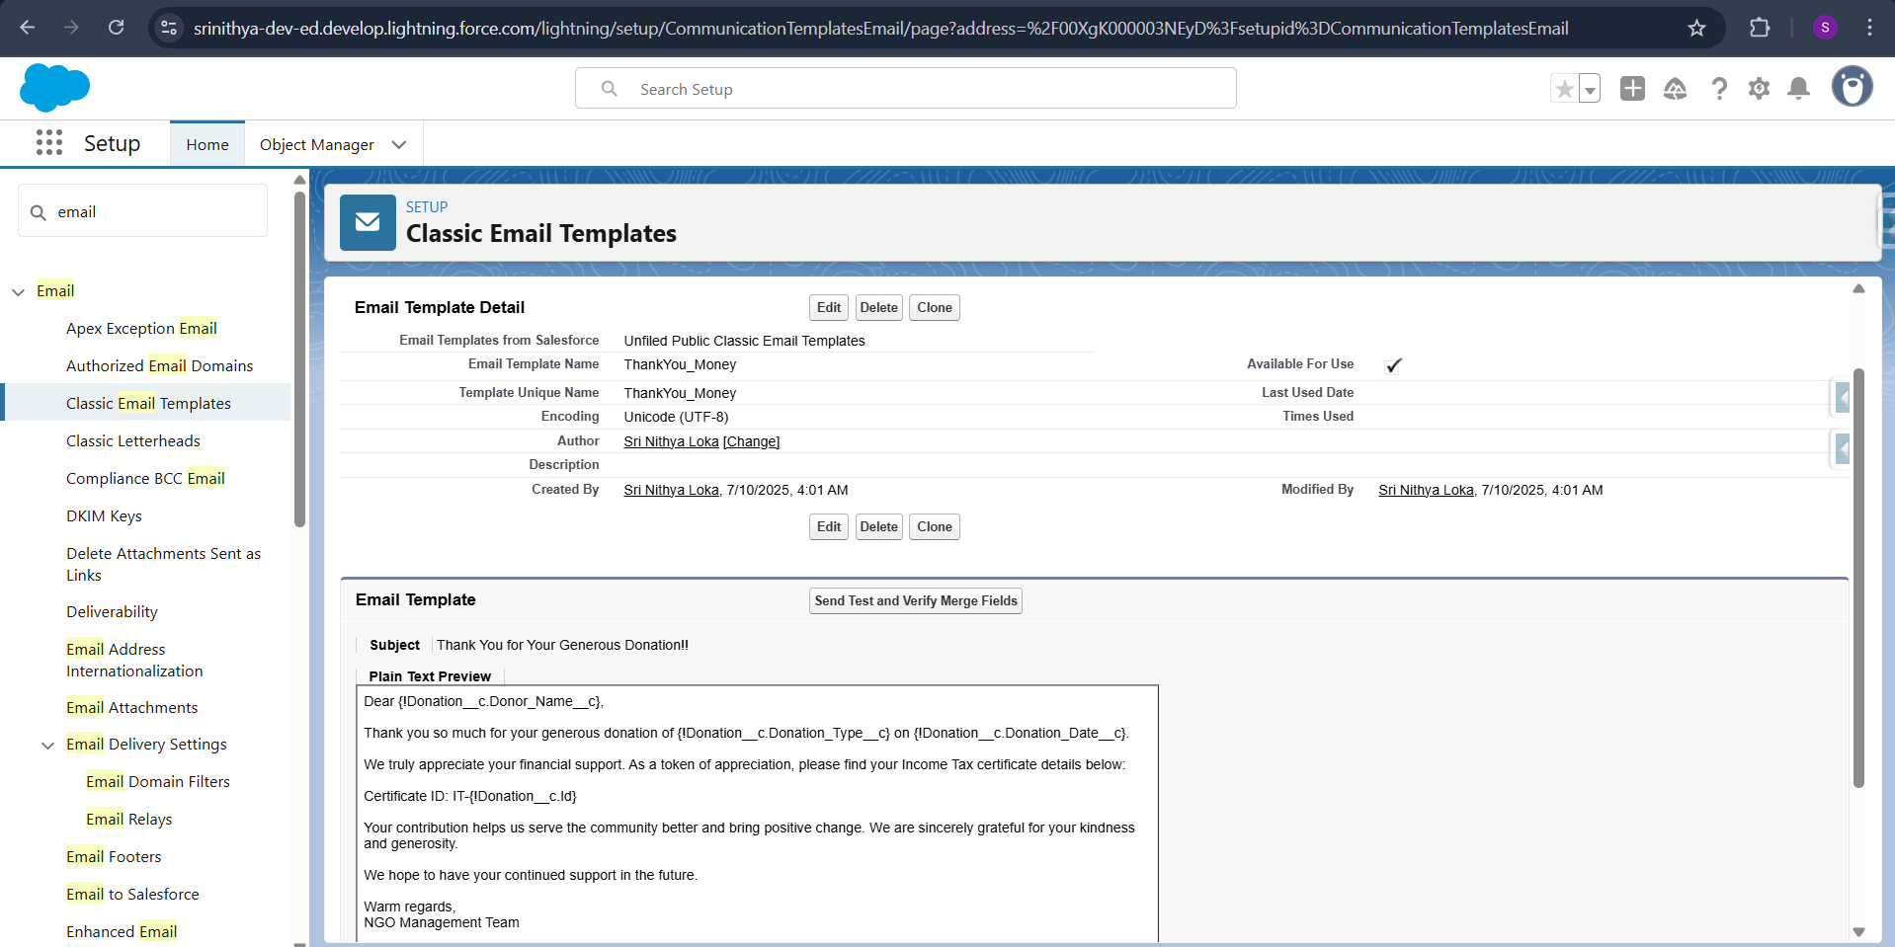

- Choose Text -> Folder: Unified Public Classic Email Templates -> Check Available for use
- Email Template Name: ThankYou_Other
- Subject: Thank You for Your Kind Donation!!
- Email Body:
Dear {!Donation__c.Donor_Name__c},
Thank you so much for your thoughtful donation of {!Donation__c.Donation_Type__c} on {!Donation__c.Donation_Date__c}.
Your support helps us provide essential services and make a meaningful difference in the lives of those we serve.
We are truly grateful for your contribution and hope to receive your continued support in the future.

Warm regards,
NGO Management Team
- Click Save.

- Choose Text -> Folder: Unified Public Classic Email Templates -> Check Available for use
- Email Template Name: Occassion_Email_Template
- Subject: Happy {!Donation__c.Occasion__c}, {!Donation__c.Donor_Name__c}! 🎉
- Email Body:
Dear {!Donation__c.Donor_Name__c},
Wishing you a very happy {!Donation__c.Occasion__c}! Thank you for being a part of our community and supporting our mission.
Warm regards,
NGO Management Team
- Click Save.

- Choose Text -> Folder: Unified Public Classic Email Templates -> Check Available for use
- Email Template Name: Monthly_Reminder_Template
- Subject: Gentle Reminder: Your Monthly Donation Matters ❤️
- Email Body:
Dear {!Donation__c.Donor_Name__c},
We noticed that you haven't made your monthly donation for this month. Your consistent support is vital to continue our programs.
Please consider donating again today.
Warm regards,
NGO Management Team
- Click Save.

- Choose Text -> Folder: Unified Public Classic Email Templates -> Check Available for use
- Email Template Name: Volunteer_ThankYou_Template
- Subject: Thanks for Participating, {!Volunteer__c.Name}!💌
- Email Body:
- Dear {!Volunteer__c.Name},
Thank you for taking part in our event on {!Volunteer__c.Event_Participated__c} on {!Volunteer__c.Participation_Date__c}
Your efforts help us serve the community better.
We appreciate your time and support!
Warm regards,
NGO Management Team
- Click Save.

- Choose Text -> Folder: Unified Public Classic Email Templates -> Check Available for use
- Email Template Name: Acknowledge_Volunteer
- Subject: Welcome to Our Volunteer Team, {!Volunteer__c.Name}! 🌟
- Email Body:
- Dear {!Volunteer__c.Name},
Thank you for registering as a volunteer with us! We’re thrilled to have you as a part of our community.
Your willingness to give your time and energy is deeply appreciated.
Stay tuned and thank you for being a change-maker!
Warm regards,
NGO Management Team
- Click Save.

Step – 10: Creating Email Alerts
We are creating email alerts because it is an automatic email that is sent to users, customers, etc., based on trigger or condition.
So, We had created 5 email templates for those we need to create 5 email alerts.
- Quick find -> Email Alerts
- Description: Thank You Email – Money Donation
- Object: Donation
- Email Template: Select ThankYou_Money
- Recipient Type: Search: Email Field -> Drag Email Field: Email to Selected
Click Save.

- Quick find -> Email Alerts
- Description: Thank You Email – Other Donation
- Object: Donation
- Email Template: Select ThankYou_Other
- Recipient Type: Search: Email Field -> Drag Email Field: Email to Selected
Click Save.

- Quick find -> Email Alerts
- Description: Occasion Email Alert
- Object: Donation
- Email Template: Select Occassion_Email_Template
- Recipient Type: Search: Email Field -> Drag Email Field: Email to Selected
Click Save.

- Quick find -> Email Alerts
- Description: Monthly Reminder Email Alert
- Object: Donation
- Email Template: Select Monthly_Reminder_Template
- Recipient Type: Search: Email Field -> Drag Email Field: Email to Selected
Click Save.

- Quick find -> Email Alerts
- Description: Volunteer Thank You Email Alert
- Object: Volunteer
- Email Template: Select Volunteer_ThankYou_Template
- Recipient Type: Search: Email Field -> Drag Email Field: Email to Selected
Click Save.
- Quick find -> Email Alerts
- Description: Acknowledgement_EmailAlert
- Object: Volunteer
- Email Template: Select Acknowledge_Volunteer
- Recipient Type: Search: Email Field -> Drag Email Field: Email to Selected
Click Save.

Step – 11: Creating Flows
- Donor Manager send emails to the donors whenever the donation record is created. So, we use Record Triggered Flow.
- Donor Manager send emails to the monthly donors to remind the monthly donors to donate. So, we use Scheduled Flow.
- Donor Manager send emails to the donors who filled occasion in the donation form on the date of occasion to the respective donors. So, we use Scheduled Flow.
- Volunteer Coordinator send emails to the volunteers after registration & participation of the respective events.
Flows: A flow is an automation tool where we can send the emails, update fields, show forms, etc.,
- A Record-Triggered Flow runs automatically when a record is created, updated, or deleted.
- A Scheduled Flow runs at a specific time and frequency, like every day at 8 AM or every Monday, and then performs actions on selected records.
In our app we use 3 flows:
- Record – Triggered Flow -> 1. Thank You Email on Donation Flow
- Scheduled Flow -> 2. Occasion & Monthly Remainder Flow
- Record Triggered Flow -> 3. Volunteer Follow-Up Scheduler Flow
- Here, we are using 2 email templates in one record trigger flow to send emails to the donors who donates money & other things separately.
- We are using 2 email templates in one schedule flow to send emails to the donors on the occasion date to the respective donors & monthly remainders.
- We use 2 email template in another schedule flow to send volunteer participation email & New event notification mail for the volunteers.
- Quick Find -> Flows -> New Flow -> Record Triggered Flow
- Choose Object -> Donation
- Click Toolbox at top-left page
- Click New Resource -> Resource Type : Formula -> API Name: Contains_Money -> Data Type:Boolean
- Enter Formula: INCLUDES({!$Record.Donation_Type__c},"Money")
- Check Syntax -> Click Done.
- Click + Button -> Click Decision
- Label Name: Check Donation Type
- Outcome Details: Label Name: Contains Money Donation
- Condition Requirements to Execute Outcome: All Conditions Are Met (AND)
- Resource: Contains_Money, Operator: Equals, Value: True
- Click Done
- Click + Button at Contains Money Donation -> Actions->Email Alerts -> Select Thank You Email – Money Donation
- Label: Send Money Donation Email
- Record Id: Triggering Donation -> Record Id
- Done
- Click + Button at Default -> Actions->Email Alerts -> Select Thank You Email – Other Donation
- Label: Send Other Donation Email
- Record Id: Triggering Donation -> Record Id
- Done

- Quick Find -> Flows -> New Flow -> Check Schedule - Triggered Flow
- Start Date: Today, Start Time: 07:00 A.M
- Frequency: Daily
- Choose Object -> Donation
- Condition Requirements: All Conditions are Met (AND) -> Field: Email, Operator: Is Null, Value: False
: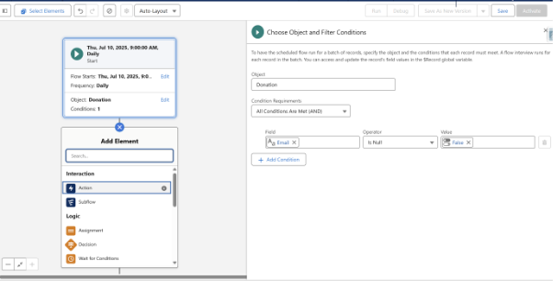

- Click Toolbox at top-left page
- Click New Resource -> Resource Type : Formula -> API Name: Send_Occassion_Mail -> Data Type:Boolean
- Enter Formula :
AND( NOT(ISBLANK({!$Record.Occasion_Date__c})), TODAY() = {!$Record.Occasion_Date__c} )

- Check Syntax -> Click Done.
- Click New Resource -> Resource Type : Formula -> API Name: Send_Monthly_Reminder-> Data Type:Boolean
- Formula: AND( NOT(ISBLANK({!$Record.Monthly_End_Date__c})), TODAY() = {!$Record.Monthly_End_Date__c} - 7 )

- Click + Button -> Click Decision
- Label Name: Occasion or Monthly Reminder
- Outcome Details: Label Name: Is Occasion Today
- Condition Requirements to Execute Outcome: All Conditions Are Met (AND)
- Resource: Send_Occassion_Mail, Operator: Equals, Value: True
- Click + at the Outcome Order
- Outcome Details: Label Name: Is Monthly Reminder
- Condition Requirements to Execute Outcome: All Conditions Are Met (AND)
- Resource: Send_Monthly_Reminder, Operator: Equals, Value: True
- Click Done
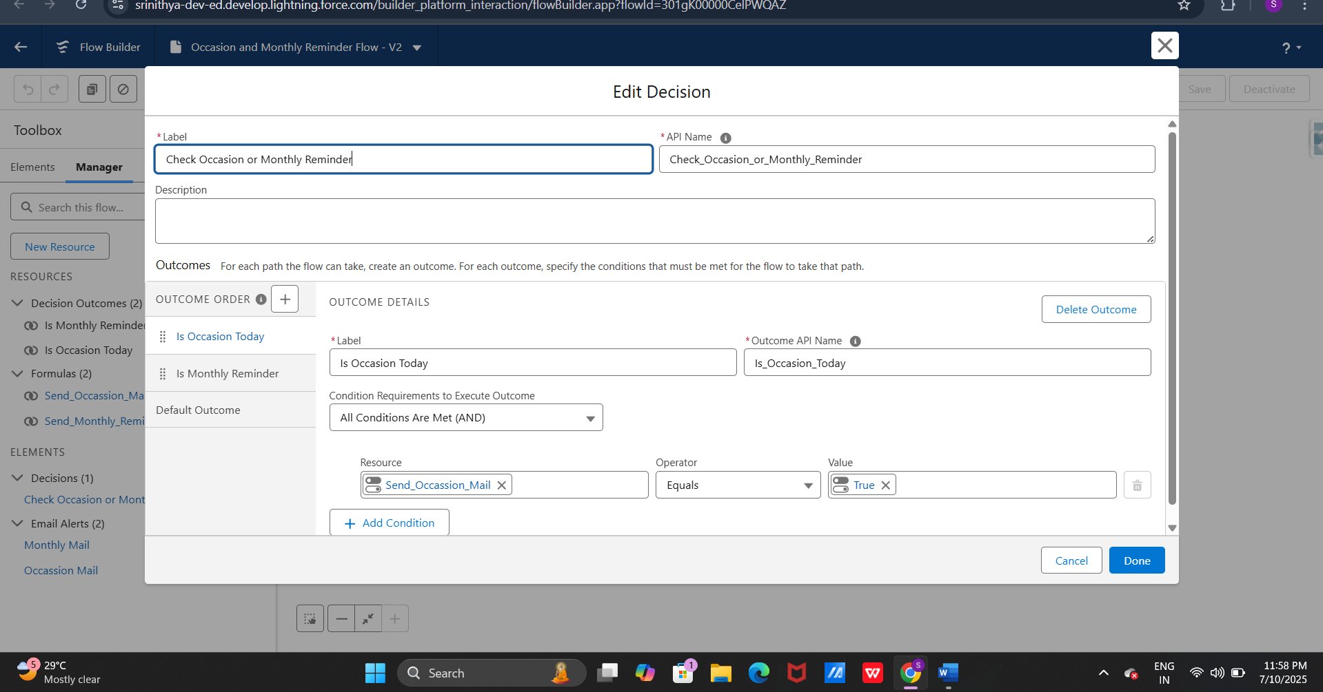
- Choose Free form
- In the tool box drag Action to the flow -> Search Email Alerts
- Select Occasion Email Alert
- Label: Occassion Mail
- Record Id: Triggering Donation -> Record Id
- Done
- Connect with the decision
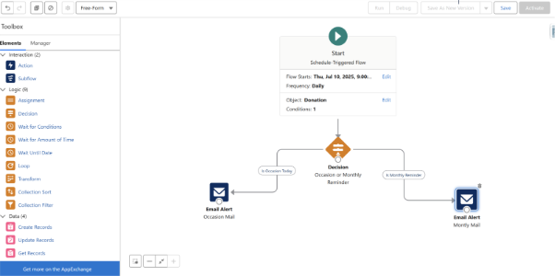

- In the tool box drag Action to the flow -> Search Email Alerts
- Select Monthly Remainder Email Alert
- Label: Monthly Mail
- Record Id: Triggering Donation -> Record Id
- Done
- Connect with the decision
- Save the flow as Occasion & Monthly Remainder

- Quick Find -> Flows -> New Flow -> Check Record Triggered Flow
- Choose Object -> Volunteer
- Click + element -> Select Decision
- Label: Check Volunteer Purpose
- Outcome 1:
Label: Registration
- Condition Logic: Resource: Click New Resource -> Resource Type: Formula -> API Name: Send_Acknowledgement_Mail -> Data Type:Boolean
Enter Formula: AND(
$Record.RecordType.DeveloperName = "Volunteer_Registration",
$Record.Wants_Notifications__c = TRUE
)
- Check Syntax -> Click Done.
- Resource: Send_Acknowledgement_Mail , Operator: Equals, Value: True

- Outcome 2:
- Label: Participation
Condition Logic: Resource : New Resource -> Resource Type: Formula -> API Name: Send_VolunteerParticipation_Mail-> Data Type:Boolean
- Enter Formula: NOT(ISBLANK({!$Record.Event_Participated__r.Event_Date__c}))
- Check Syntax -> Click Done
- Resource: Send_VolunteerParticipation_Mail, Operator: Equals, Value: True

- Click + button under Participation -> Actions -> Email Alerts
- Select Volunteer_ThankYou_Template Email Alert
- Label: Send Participation ThankYou
- Record Id: Triggering Volunteer -> Record Id
- Done
- Click + button under Registration -> Actions -> Email Alerts
- Select Acknowledgement_EmailAlert
- Label: Send Acknowledgment Notification
- Record Id: Triggering Volunteer -> Record Id
- Done
- Save the flow as Volunteer Follow-Up Scheduler
Step 12 – Create Reports & Dashboards
- First Enter 10 records to Event object manually

- Creating report for Donation Object
- First Enter 15 records to donation object manually
- Go to custom app NGO Management ->reports->New-->All-->search for Donation object-->start report
- Top donar
- Select the fields on the left side Name and donation amount
- Grounp by row Donation Amount
- Then run
- Save as Top Donar
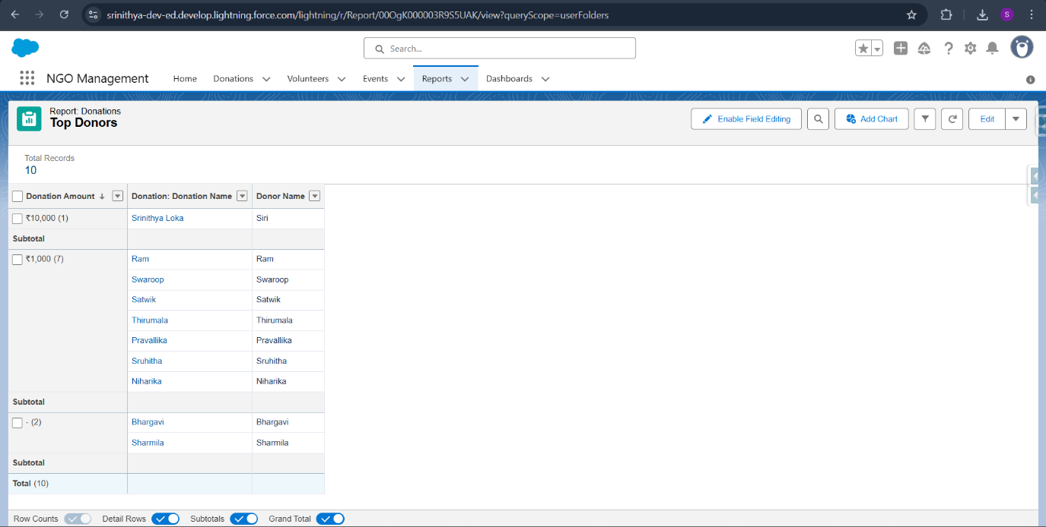

- Donations by Occasions
- NGO Management -->Reports-->New reports
- Select the fields on the left side Donation Name and Occassion Date
- Grounp by row Occassion
- Then run
- Save as Donation By Occassions
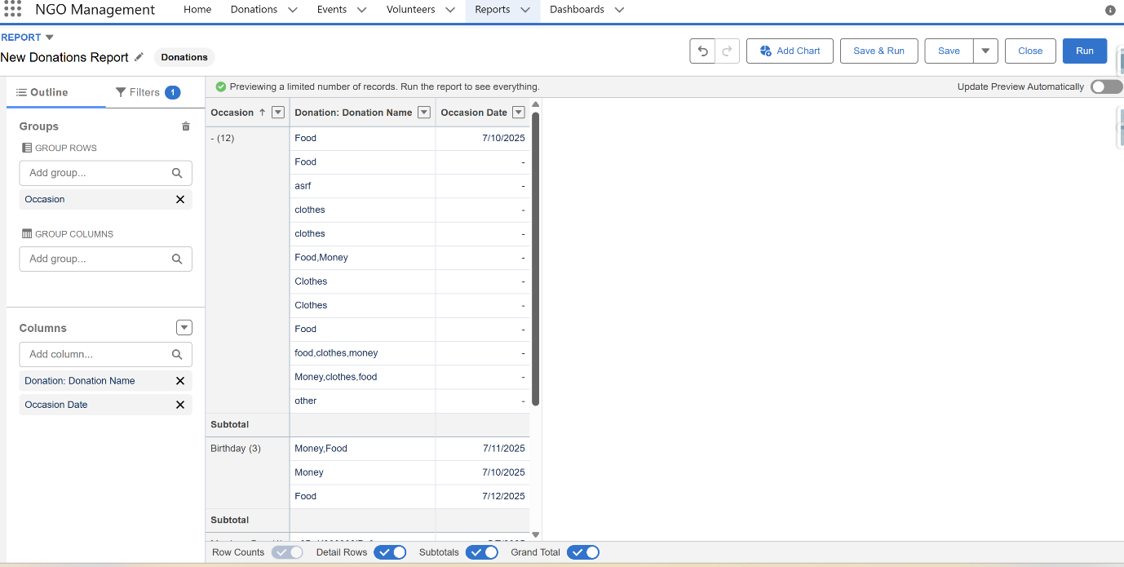

- Creating report for Volunteer Object
- First Enter 15 records to Volunteer object manually
- Go to custom app NGO Management ->reports->New-->All-->search for Volunteer object-->start report
- Volunteer per Event
- Select the columns on left side Volunteer Name
- Group by row Event Participated
- Then run
- Save as Volunteer per Event
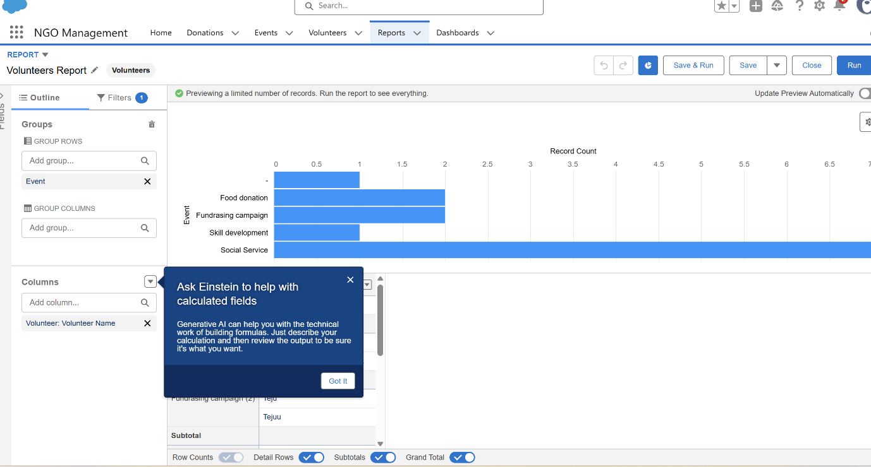
Creating Dashboards
- NGO Management -->Dashboard-->New
- Save as NGO Analytics
- Click on Widget and select the reports created before
